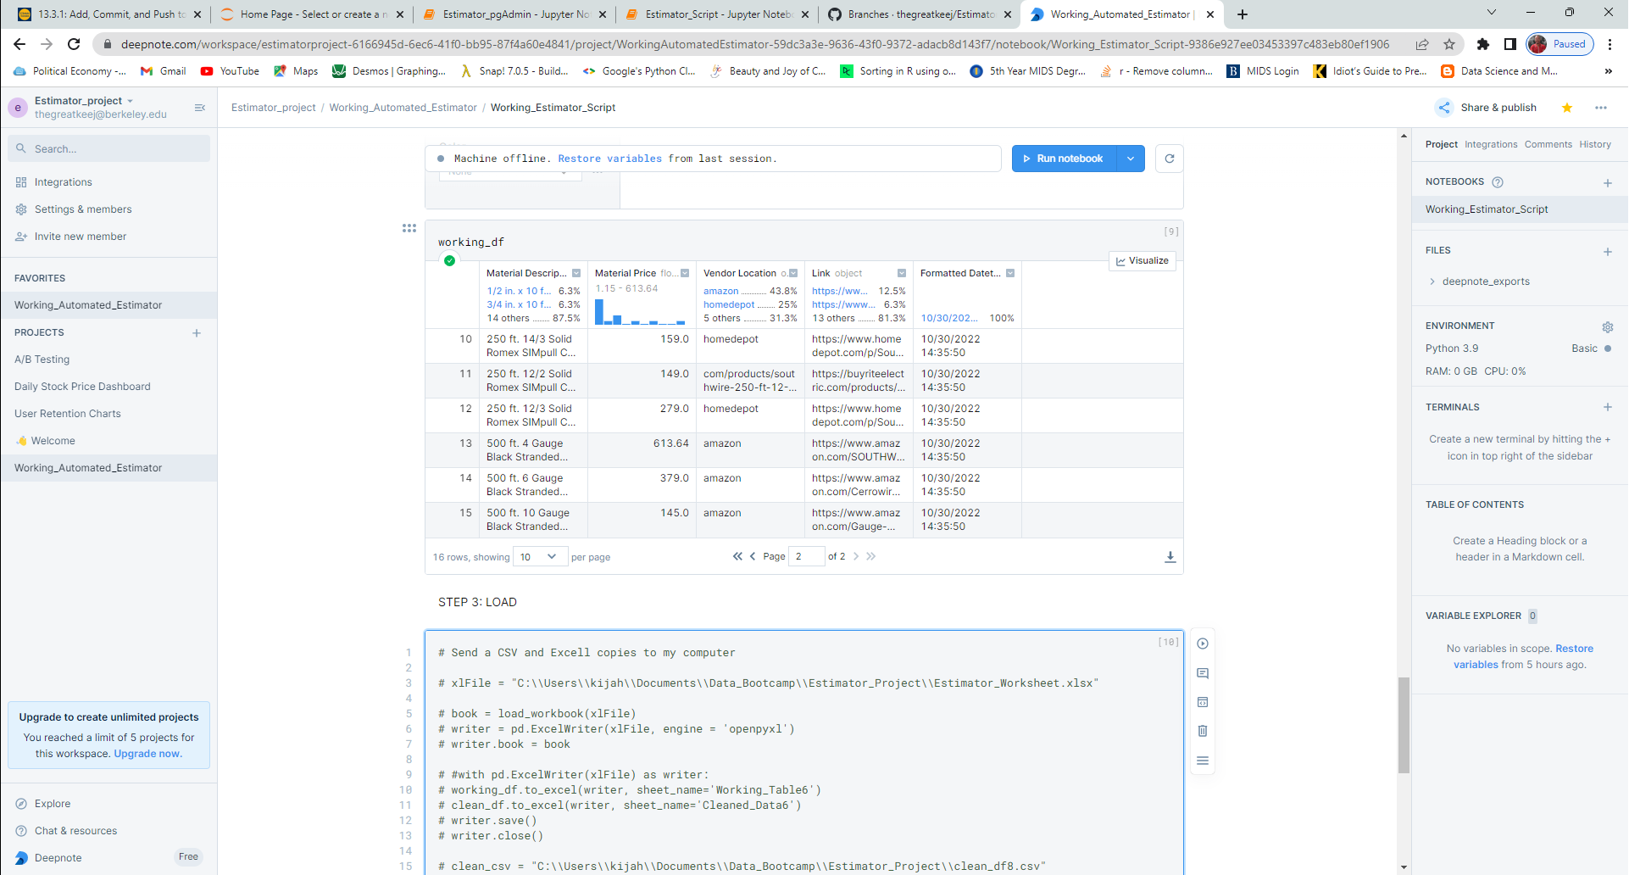

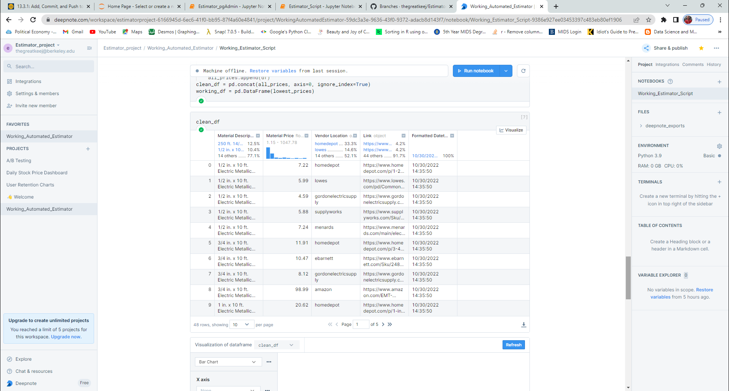

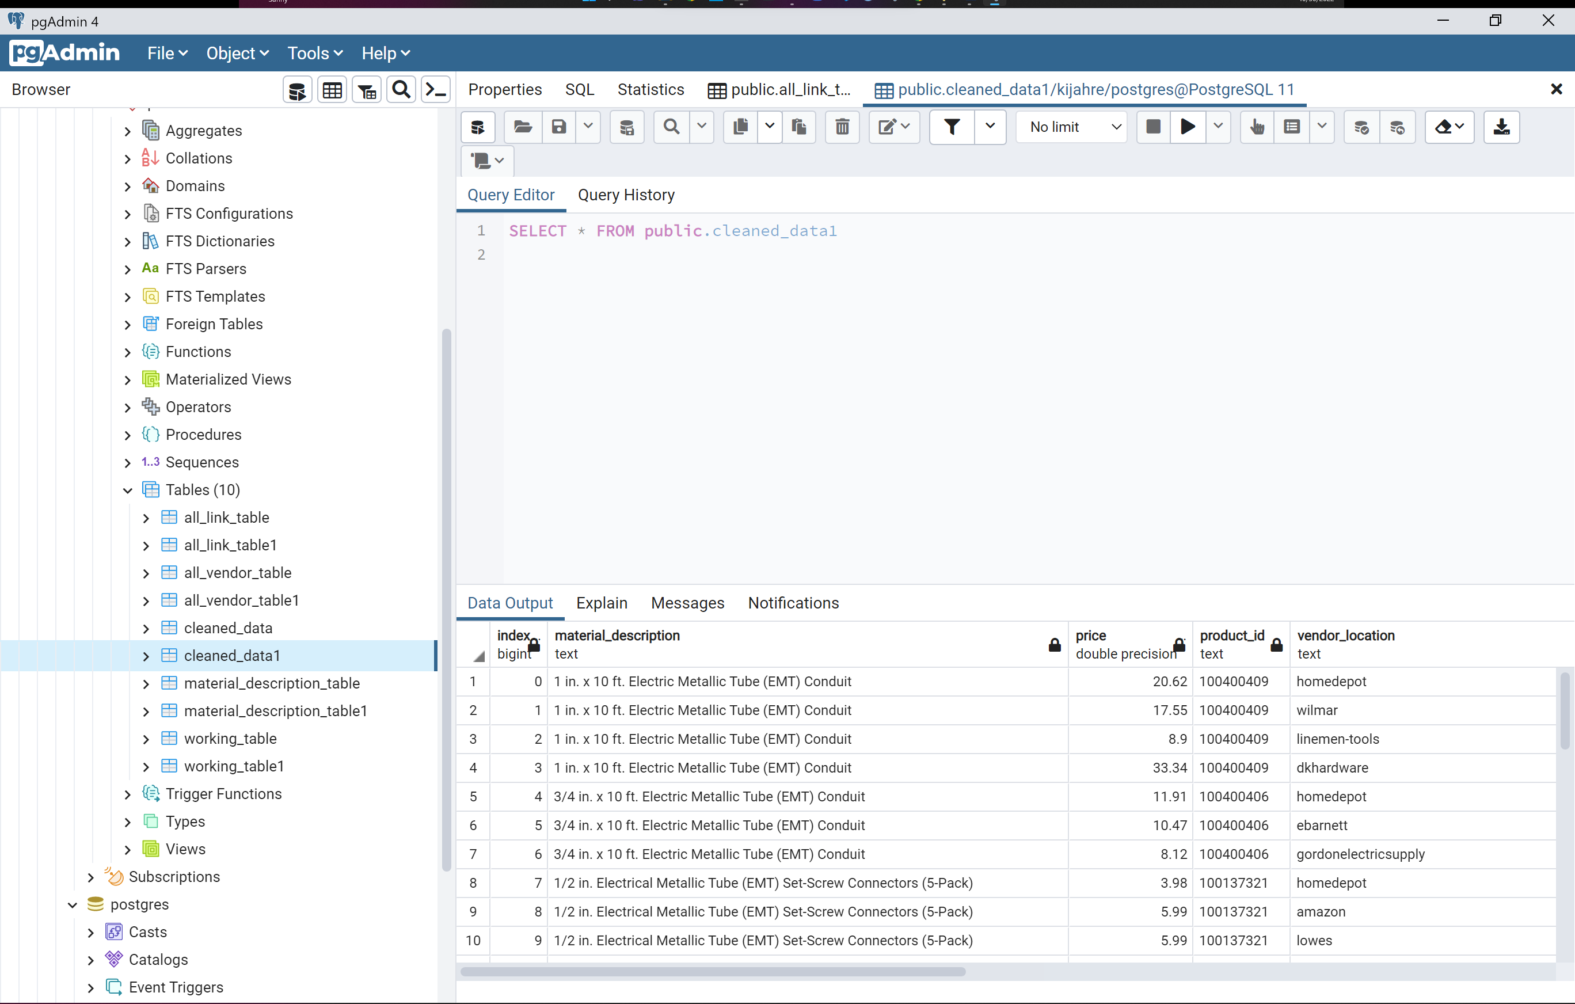

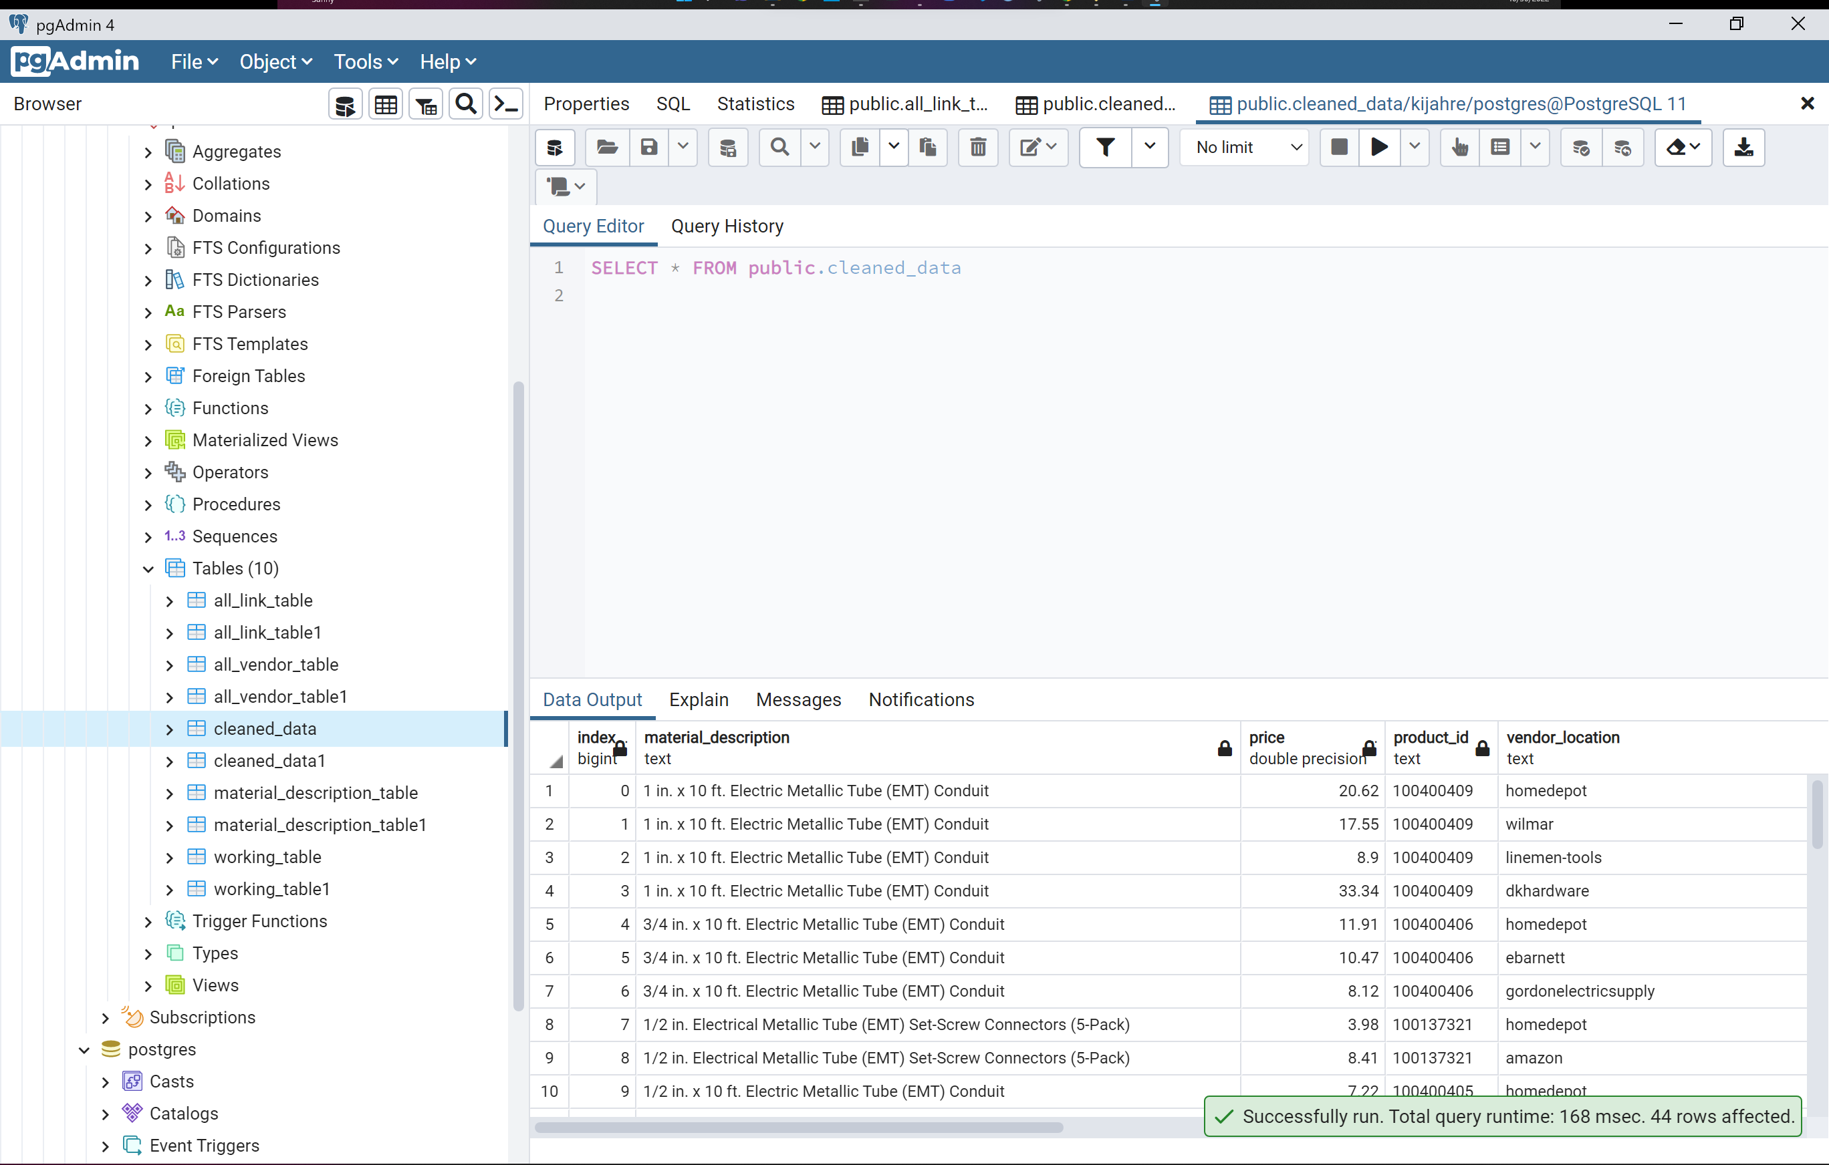

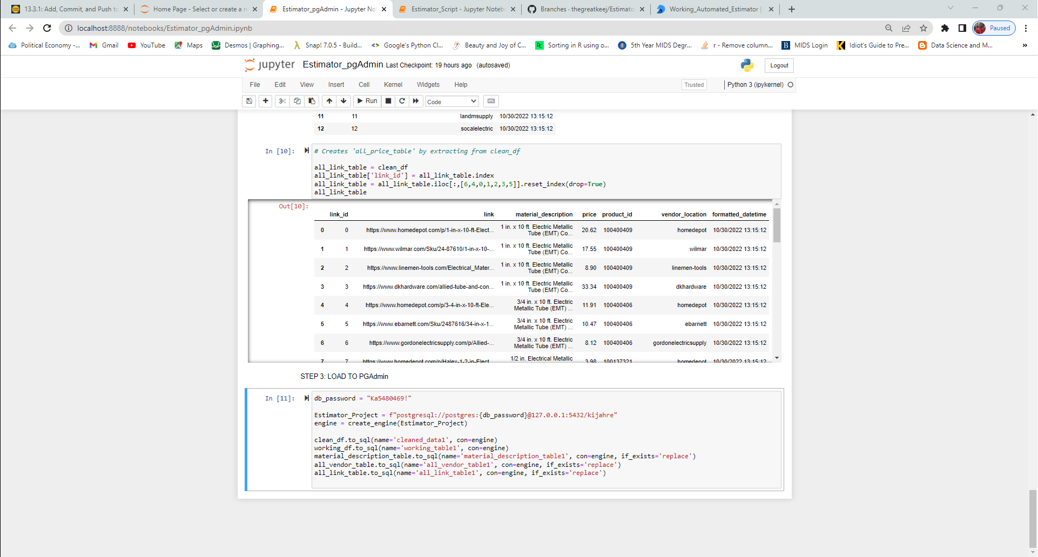

* I found a website that will run our script on a timed basis and hosts the results: deepnote link: <https://deepnote.com/workspace/estimatorproject-6166945d-6ec6-41f0-bb95-87f4a60e4841/project/WorkingAutomatedEstimator-59dc3a3e-9636-43f0-9372-adacb8d143f7/notebook/Working_Estimator_Script-9386e927ee03453397c483eb80ef1906>
* I recreated a “Normalized” set of schemas for the data:
* I sent data to pgAdmin and created databases.
* I consolidated (9) days of data and started creating a model that will establish:
  + a correlation between cable and wire
  + a correlation between conduit and fittings
  + Predict which vendor will offer the cheapest priced item
  + Predict which day of the week will offer the cheapest priced item
* I cannot export from deepnote at the moment. I know it will allow because I’ve done it once before. I suspect it won’t because I am on the free tier.
* I cannot export PGAdmin db’s so that they re-write existing db in-place
* We need historical data to create a predictive model and I don’t have it yet.

